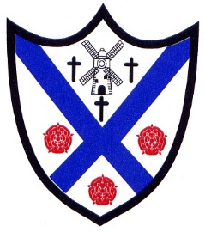

**School Term 2026/27**

**Autumn Term 2026**

**Starts:**Thursdays 3 September 2026  
**Half term:**Monday 26 October- Friday 30 October 2026  
**Ends:** Friday 18 December 2026

**Spring Term 2027  
  
Starts:**Tuesday 5 January 2027  
**Half term:**Monday 15 February - Friday 19 February 2027  
**Ends:** on Thursday 25 March 2027

**Summer Term 2027**

**Starts:** Monday 12 April 2027  
**May Day:**Monday 3 May 2027  
**Half term:**Monday 31 May - Friday 4 June 2027  
**Ends:** Wednesday 21 July 2027

Total number of openings – 190

**INSET Days (Staff only)**

Tuesday 1 September 2026

Wednesday 2 September 2026

Friday 23 October 2026

Monday 4January 2027

Thursday 6 May 2027